**Answer a(i)**   
Below variables affect profitability **positively**.  
1. Price of the inn

2. College students in the area  
  
And below variables affect profitability **negatively**.

1. State population per inn

2. Square root of the median income of the area

Yes, it makes sense and below are the comments to support our argument.

1. More the price of the inn, more will be the profitability as these variables are directly proportional.

2. More the college students in the area, more the expectation of guests like vising parents (family) and more occupancy in the hotels while new students arrive in the area. Thus, profitability is expected to be higher.

3. More the state population, means it’s crowded and less expectation of tourists. This will obviously lower the profitability of the hotels.

4. If the median income of the area is less, it is more likely that the people in the area can’t afford expensive life style and this will lead to lower profitability with lower prices.  
  
**Answer a(ii)**

Regression equation is given as:  
Profitability = 39.05 – 5.41*(State population per inn) + 5.86*(Price of the inn) – 3.09*(Square root of the median income of the area) + 1.75*(College students in the area)

Now for hotel 1, we can simple substitute the values of our variables for hotel 1 from the given input table.

Then, Profitability = 39.05 – 5.41*(-1.00) + 5.86*(-0.30) – 3.09*(-0.81) + 1.75*(-0.54)

= 44.24

**So, predicted profitability would be (44.24).**

**Answer a(iii)**   
We can calculate the profitability in the excel with the given equation and using variable values in the input table. (Excel file with used formulas is attached with tab name as profitability).



From the above table, we can see the profitability for all the hotels.

**Maximum profitability: 53.38 for ‘Hotel 2’  
Minimum profitability: 23.45 for ‘Hotel 8’**

**Answer b(i)**   
We can see that hotel 2 is the most profitable hotel and it costs equal to our available budget that is $10M. So, **we will buy one ‘Hotel 2’** for the maximum profitability among all the hotels with greedy approach.

**Answer b(ii)**  
As we are just buying ‘Hotel 2’ which has the profitability ’53.38’. Thus, total **profitability would be ’53.38’.**

**Answer b(iii)**  
No, it won’t be a good approach as we should look for options where we can get more profitability with purchasing less cost hotels and giving a sum of profitability which would be higher than the profitability of just one hotel using greedy approach. For achieving higher profitability, we should look for hotels having higher profitability to cost ratio.  
If we want to maximize the average profitability of the hotels we will select, we would get better results with optimized value of profitability.

With greedy approach, we will buy ‘Hotel 2’ and ‘Hotel 6’ (Total buying cost $10M + $8.95M = $18.95M which leaves $20M - $18.95M = $1.05M which is less than $2.925M required to purchase third most profitable hotel ‘Hotel 1’) as these have maximum profitability among all hotels and these will be giving total profitability of (53.38 + 49.10=) ‘102.48’.

**Answer c(i)**   
We are trying to maximize the total predicted profitability with making appropriate selection of the available hotels at different locations with given attributes. Additionally, we have a constraint on our overall budget which is $10M.

**Decision variable:** Could be defined as selection to purchase ‘Hotel 1’, ‘Hotel 2’,… and so on. Thus, we would have total of 16 decision variables and all of them would be binary in nature (either 0 or 1) as either we will purchase a hotel (value would be 1) or will not purchase that hotel (value would be 0).  
We will define decision variables in form of an array X[i] where i will vary from 1 to 16.

**Objective function:** could be given by the sum of profitability of purchased hotels. For our problem,  
Maximize Profitability: where X[i] is our decision variable and Profitability[i] is profitability of ith hotel.

**Constraint:** We have a constraint on budget which states that total price to purchase hotels could not exceed $10M.  
Total budget: where X[i] is our decision variable and Price[i] is price to purchase ith hotel.

**Answer c(ii)**   
On solving the above formulation using Excel solver, we can see below output. (Tab ‘Optimization_c’ represents the solution in Excel file).



**Thus, optimal solution is to buy total 7 hotels (Hotel no 5, 10, 11, 12, 13, 15, and 16 giving total profitability of ‘269.92’.**

We can solve this problem using AMPL as well. Below screen shot shows the optimal solution with all decision variables and objective function.

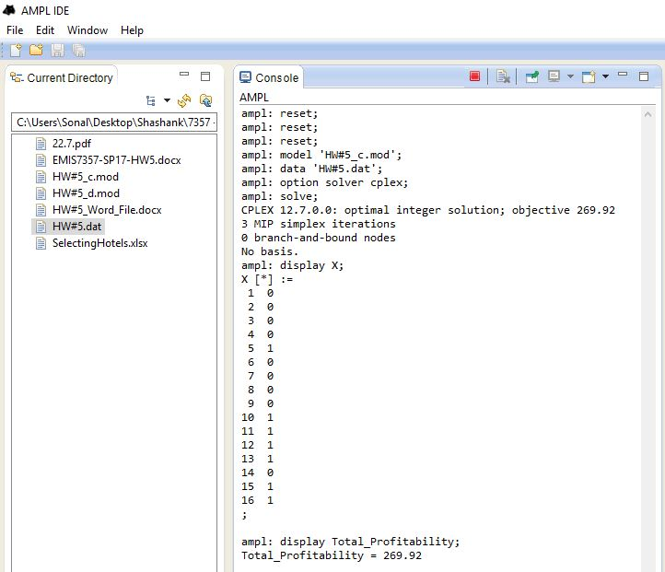

**Answer c(iii)**   
Yes, this optimal solution makes more sense as overall profitability has been increased tremendously (from 53.38 to 269.92) in comparison to greedy approach.

Greedy solution considers only highest profitability despite of investment in it while optimized solution looks for increasing the total profitability with minimizing investment so that we can purchase more hotels. This is the reason optimal solution using optimization is better than greedy approach.

**Answer d(i)**   
New constraint to the model would be given by ‘Total number of hotels in any city should be less than equal to 2’.  
Mathematically,   
New constraint for Fresno: X[2] + X[3] + X[4] + X[5] <= 2  
New constraint for Los Angeles: X[7] + X[8] + X[9] <= 2  
New constraint for South Lake Tahoe: X[10] + X[11] + X[12] + X[13] + X[14] + X[15] + X[16] <= 2

We don’t need to add similar constraint for Eureka and Long Beach as they just have one hotel which is already in constraint boundary.

**Answer d(ii)**   
We can solve this problem using AMPL after adding new constraints to old formulation. Below screen shot shows the optimal solution with all decision variables and objective function.

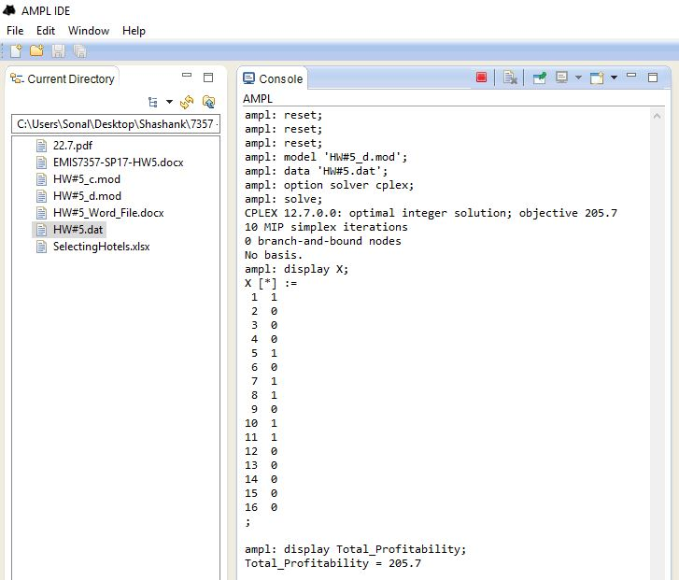

On comparing this to the previous solution, we see that profitability is reduced as we were not able to select all most profitable hotels (being on same location) but we have more diverse hotel locations which is good in business point of view.

**Answer e**We have three solutions for the same problem using greedy approach, optimization of predicted profitability irrespective of number of hotel locations in any city, and optimization of predicted profitability using constraints that gives diverse locations (not more than two hotels at single location).

La Quinta should not use greedy approach anyhow as this doesn’t consider value of investment but just looks for maximum profitability. Thus, we end up with very lower profitability with our available budget.  
However, optimization is the best solution which considers and maximize profitability to investment ratio. Again, we have added a constraint in part (d) solution that allows us maximum of two hotels at a single location and we would recommend La Quinta to use this solution as this gives diversity with higher (not the maximum) profitability. Although, this solution is lesser than part (c) solution, but this overcomes problems like natural disaster, other poor weather conditions, and seasonality. To be more precise on this, we can have 5 hotels at a single location to maximize profitability but this would risk associated with problems defined above.

La Quinta can improve their regression model considering more important factors like competitors’ data, tourist spots and average number of tourists, seasonality (which season is more profitable), and availability of local labor with information on wages. And then we can improve optimization model to improve profitability.